Peer review for John Herrlin jh222jx och Rasmus Sjöström , https://github.com/jherrlin/1DV607/tree/submit1

# Software

The program is written in python which I am not familiar with so I can’t really give any feedback on the code itself or how it reflects the design

The installation was demanding with several new software components, python, python-urwid, VC++ for python. After unpacking and installing I still failed with a command

  
I don’t know what IDE to develop Python in, I could not find any project file. I installed an add on Visual Studio for Python but that didn’t help (It rather ruined my VS, can’t open any C# projects any more)

At that point I gave up.

# Design

Sequence diagrams are good and corresponds to the implementation but the methods should have dotted lines for to the calling component indicating something is returned [Larman Figure 10.2], e.g. the case for Controller call to User.getall() in the modell.

The class diagram indicates the View uses the controller. It should be the other way around according to the PHP lectures (there is no true defined MVC definition to reference. Some definitions have slightly different opinions on the connections between Model-View-Controller when you search the web), but this is how it has been presented to us

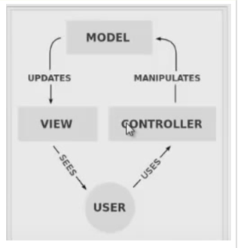

**As a developer would the diagrams help you and why/why not?**

Yes they are easy to understand

**What are the strong points of the design/implementation, what do you think is really good and why?**

Can’t say.

**What are the weaknesses of the design/implementation, what do you think should be changed and why?**

Cant say.

**Do you think the design/implementation has passed the grade 2 criteria?**

Cant say.

References:

Larman C., Applying UML and Patterns 3rd Ed, 2005, ISBN: 0-13-148906-2